# **CTF Challenge: Website Security Assessment - Using SectigoStore**



# **1. Introduction**

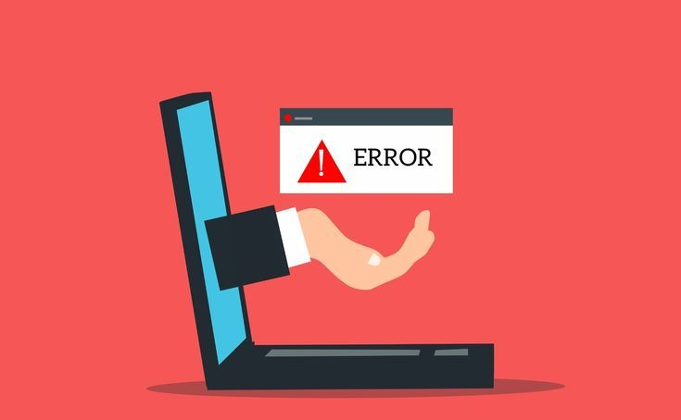

SSL Checker by SectigoStore is a tool that allows you to analyze SSL/TLS certificates installed on a website. This challenge will introduce you to using SSL Checker by SectigoStore to assess the SSL/TLS configuration of a specific domain.

# **2. Tools and Requirements**

Access to the internet and open SSL checker by SectigoStore

# **3. Scenario**

You are a cybersecurity analyst tasked with verifying the SSL/TLS configuration of a client's website. Your objective is to use SSL Checker by SectigoStore to determine the status of the SSL/TLS certificates and identify one relevant detail associated with the certificate.

# **4.Process to follow while performing CTF**

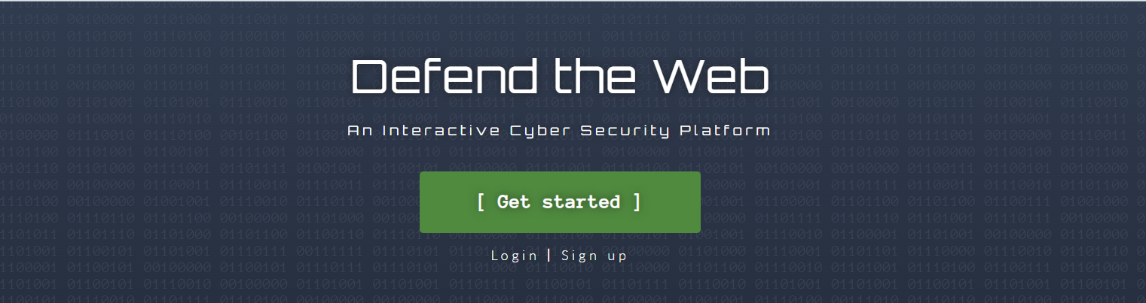

1. Go to **SSL Checker by SectigoStore:**

**https://sectigostore.com/ssl-tools/ssl-checker.php**

2. Search: Enter the domain[**https://defendtheweb.net/**](https://defendtheweb.net/)in the Server hostname and click on check option.

3. Solve the CTF.

# **5. Let’s Begin the Challenge**

**Question**

**Flag 1: What is the Server Type?**

**Answer:** openresty

**Flag 2: Mention the name of certificate issuer?**

*Answer: R11*

**Flag 3: What is the Location in the chain?**

*Answer: US*

**Flag 4: What is the name of the Issuer in the chain?**

*Answer: ISRG Root X1*

**Hint:**



